**When It Comes to Household Chemicals – Change Is A Good Thing!**

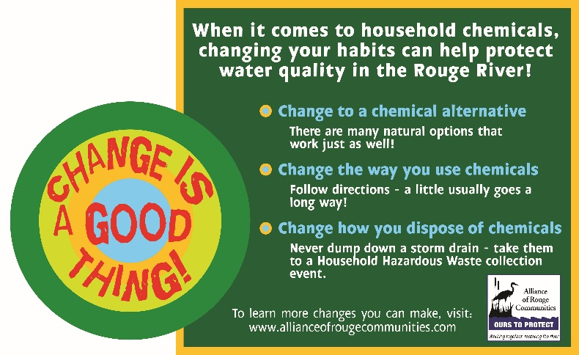You know that age-old phrase - “change is a good thing!” When it comes to household chemicals, changing your habits in your home, yard, and with your vehicles can help protect water quality in the Rouge River watershed. Everyone who lives in Michigan lives in a watershed! When rain and snow/ice melt travel across the land (watershed) and into storm drains, it is called stormwater or runoff. As this runoff travels, it picks up trash, animal waste, chemicals, sediment, and dissolved substances along the way until it empties into streams, rivers, and lakes. These bodies of water impacted by runoff provide recreational opportunities, habitat for wildlife, and even drinking water for communities.

Change is a good thing! Reduce the amount of chemicals you use by finding a natural alternative to your household cleaners like peroxide, olive oil or lemon juice. When washing your vehicles use your local car wash which sends the wash water to the sewer system to be treated or just use water, a coarse cloth and elbow grease! In your yard seek alternatives to fertilizers like mulching your grass which acts as a natural fertilizer. In addition to finding chemical alternatives, change how you use chemicals. This can help improve water quality by ensuring you are applying them as directed, in the proper amount, and storing them safely to reduce risk of leaks. Finally, and maybe most importantly, dispose of chemicals through a take-back program or at a Household Hazardous Waste collection event. Never dump fertilizers/pesticides, vehicle fluids, excess windshield washer fluid or other chemicals down a storm drain or onto the ground. By incorporating these healthy habits, you are protecting not only the health of our watershed but also ourselves and everything downstream. For more healthy habits related to household chemicals and other ways you can protect water quality in the Rouge River visit [www.allianceofrougecommunities.com/watershed.html](http://www.allianceofrougecommunities.com/watershed.html).